shot drill | 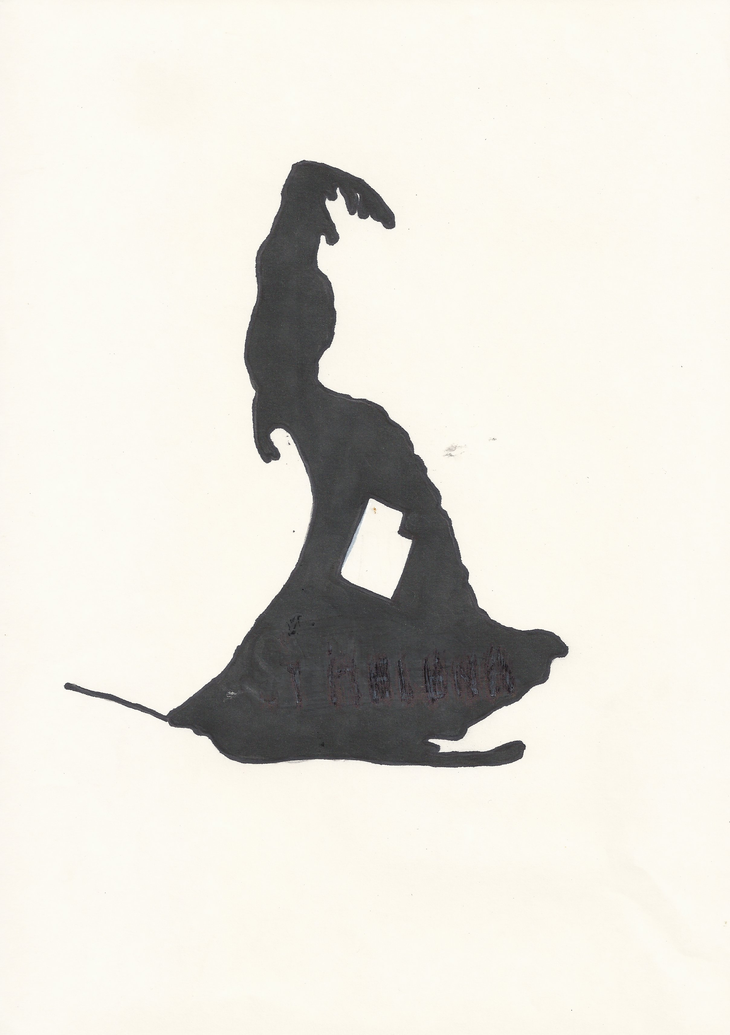
punishment at St Helena Penal Establishment
▪ The St Helena Island Community ▪ www.sthelenacommunity.com.au
July 2019

Shot Drill

August 17 1868: William Reed - 14 days shot drill for Disobedience of Orders.
As one of the first prisoners issued with shot drill as a punishment, Reed was able to display to Superintendent John McDonald that ‘the shot drill has been introduced with a very good effect, the prisoners dread shot drill more than any other kind of punishment, it will have good effect in preserving prison discipline on the island.’
Shot drill involved a prisoner carried a 24lb, or 11 kg, cannon ball up and down the length of the lumber yard for 1hour and 15 minutes. Prison warders watched from the cat walk above, to ensure that the prisoner walked continuously, only placing the ‘shot’ down as they turned at the end of the lumber yard. As a punishment, it introduced a monotonous, mindless routine designed to sap the physical strength and mental clarity of a prisoner.

Shot drill was commonly given as a punishment for insubordination, laziness and disobedience and was usually issued for 7 or 14 days, taking place each day after the working day was completed.
Source: Superintendent’s Report August 1868 COL/A111/68/2805

Consider:
- Flogging, Shot Drill and Solitary confinement were the most common form of punishment in the first 25 years of the penal establishment. How does this link back to the imperial system for dealing with crime?
- Why would prisoners dread shot drill more than anything else?
- From the mid 1890’s, punishments in the form of loss of indulgences, being held in a ‘light’ cell, and additional sentence were more commonly used. When was flogging discontinued in Australia? In England?
- Explain the differences between punishment and reform as a means for changing prisoner behavior.

